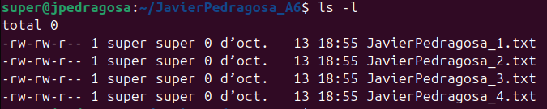
ACTIVITAT 6 - Drets d’usuaris en GNU/Linux
“VISUAL THINKING” kick-off

- Completar aquest document amb les teves respostes en aquest color blau.
- Puja al Moodle el teu fitxer de respostes en format PDF amb el nom Usuari_A6.pdf

- To each section you have to provide valid commands:
1.1 Create a new folder (TeuNom_A6) to share resources between users.
mkdir JavierPedragosa_A6
1.2 Create four users (TeuNom_U1... _U4).
sudo useradd javierpedragosa_u1 &&
sudo useradd javierpedragosa_u2 &&
sudo useradd javierpedragosa_u3 &&
sudo useradd javierpedragosa_u4
1.3 Create two groups (TeuNom_G1 ... _G2).
sudo groupadd javierpedragosa_g1 && sudo groupadd javierpedragosa_g2
1.4 Assign two users to one group and the other two to the other group.
sudo usermod -a -G javierpedragosa_g1 javierpedragosa_u1 &&
sudo usermod -a -G javierpedragosa_g1 javierpedragosa_u2 &&
sudo usermod -a -G javierpedragosa_g2 javierpedragosa_u3 &&
sudo usermod -a -G javierpedragosa_g2 javierpedragosa_u4
1.5 Check that the users belong to the corresponding groups.
grep javierpedragosa_g1 /etc/group && grep javierpedragosa_g2 /etc/group
1.6 Create five files (TeuNom_1...4.txt) in the folder created in 1.1.
touch ./JavierPedragosa_A6/JavierPedragosa_1.txt &&
touch ./JavierPedragosa_A6/JavierPedragosa_2.txt &&
touch ./JavierPedragosa_A6/JavierPedragosa_3.txt &&
touch ./JavierPedragosa_A6/JavierPedragosa_4.txt

- To each section you have to provide valid answer.
Use the command ls -l to list the permissions, group and user of the 1.1 folder and its files:
2.1 Take a screenshot of the command and the list obtained.

2.2 Explain the meaning of the first character that appears in the list.
I will assume that by the first character on the list you mean the first character after the “total 0” line, which is a “-”. That character means that those elements we are seeing in the list are files.

2.3 Explain all the possible values of the first character that appears in the list.
From what I have been able to gather on-line, there are 8 possible values for that first character:
1. “-” which means that is a regular file.
2. “d” which means that is a directory.
3. “c” which means that is a character device.
4. “l” which means that is a symlink.
5. “p” which means that is a named pipe.
6. “s” which means that is a socket.
7. “b” which means that is a block device.
8. “D” which means that is a door, which is not common on Linux but has been ported.
2.4 Explain the meaning of all the characters that refer to permissions.
The string of permissions is formed by 9 characters which divide in to 3 groups of 3. The first 3 characters refer to the permissions of the user who has created that file or directory, the next three refer to the permissions that the group where the user belongs have, and the last three refer to the permissions that all the other users have on that file or directory.
In each one of the three groups, there can be 4 different characters. There are 3 permissions, read, write and execute, which correspond to the characters r, w and x. They are always in the same order. If all permissions were granted to everybody (user, group and others), the permissions would read as rwxrwxrwx. The fourth possible character is -, which means that permission is not granted to that specific user/group.
  - Explain the meaning of the 3 groups of permissions in this situation: drwxrw-r-r--
The first group is the owner, which has all of the permissions. The secound group would be the group where the owner belongs, and it has permission to read and write, but not to execute. Lastly, the third group which would be all the other users and groups does not make any sense, it looks like an error. Seemingly, that group has the permission to read, but twice, and no other permissions.
- Explain, using an example, how the following commands work and their main options:
3.1 chmod
3.1.1 Summarize with your words the utility of the chmod instruction
Chmod is used for modifying the permissions on a file or folder.
3.1.2 Specifies the chmod instruction in octal that does the following:
(for example, ‘chmod 123 arxiu.txt’)
a. All users can read and modify ‘arxiu.txt’.
chmod 666 arxiu.txt
b. All users can read, modify and execute ‘arxiu.txt’.
chmod 777 arxiu.txt
c. The owner of the archive can read, modify and execute ‘archive.txt’, others can only read and modify and not execute.
chmod 766 arxiu.txt
d. The owner can read and modify ‘arxiu.txt’, the rest can only read.
chmod 644 arxiu.txt
e. Read and write rigths only to the owner of arxiu.txt and no permissions to other users.
chmod 600 arxiu.txt

3.1.3 Indicate the chmod instruction in character mode that does the following
(for example, ‘chmod o-rwx folder’, chmod o+r arxiu.txt)
a. To the subdirectory ‘folder’ gives read, write and execute permissions to the owner, read and execute permissions to the group, and removes all permissions to other users both in the folder and in all its subdirectories and files.
chmod -R u=rwx, g=r-x, o= folder
b. To the subdirectory ‘folder’ gives read, write and execute permissions to the owner, read and execute permissions to the group, and no permissions to other users in the folder and all its subdirectories, but does not change the permissions of the files.
find folder -type d -exec chmod u=rwx,g=rx,o= {} \;
c. Adds writing permissions to the owner.
chmod o+w folder
d. Removes execution permissions from all users
chmod a-x folder
e. Adds read permissions to all users
chmor a+r folder

Summarize with your words the utility of the chown instruction
Chown is used for changing the owner user of a file or folder to a different user than the current owner.

a. change the owner of arxiu.txt to the user ‘juan’.
chown juan arxiu.txt
b. change the ownership of the folder ‘project’ and all its files and subdirectories to the user ‘*carlos’.
chown -R *carlos project

a. change the owner of ‘arxiu.txt’ to ‘juan’. and the group of the archive to ‘grupojuan’.
chown juan:grupojuan arxiu.txt
b. change the ownership of ‘arxiu1.txt’, ‘arxiu2.txt’, “directori1” and “directori2” to the user “usuari4” and the group “grup4”.
chown usuari4:grup4 arxiu1.txt arxiu2.txt directori1 directori2

Summarize with your words the utility of the chrgrp instruction
Chgrp is used for changing the owner group of a file or folder.

a. change the owner group of the file ‘arxiu.txt’ to the ‘office’ group.
chgrp office arxiu.txt
b. the ‘project’ folder changes ownership to the ‘office’ group, but the folders and subdirectories within ‘project’ should not be affected
chgrp office project
c. the ‘project’ folder and all its contents change ownership to the ‘office’ group.
chrgrp -R office project

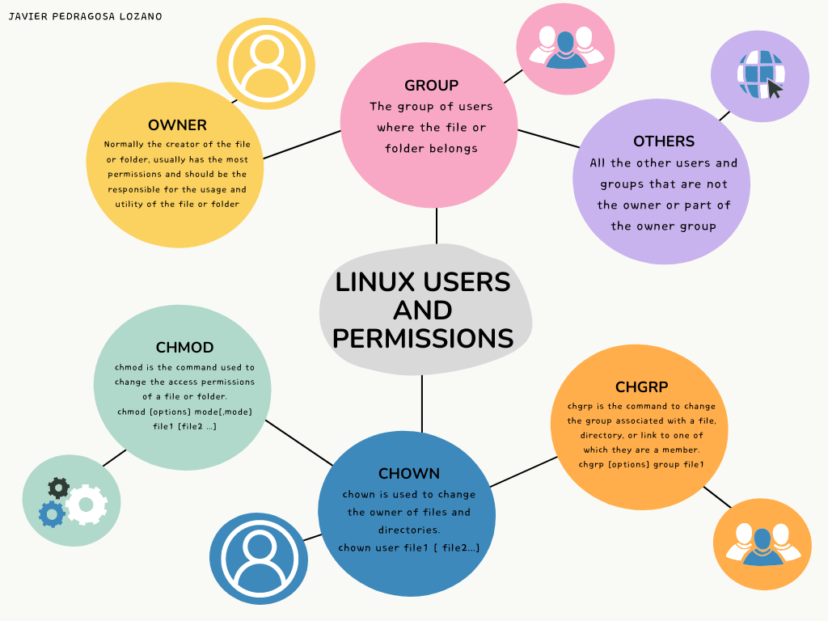
- “Visual Thinking” design
  - Research what "visual thinking" is (hint: a way of mentally representing key ideas).
  - Create your own visual thinking design to demonstrate the skills about users and permissions in Linux introduced in this activity.

